Assignment
Fundamental Theory
(LAB: 9)
NAME: Majid Ali
CMS ID: 053-25-0017
PROGRAM: Software engineering (Section: A)

Q 1:
Consider an integer array, the number of elements should be determined by the user. The elements are also taken as input from the user. Write a program to print sum, an average of all numbers, the smallest and largest element of an array.
#include <iostream>
using namespace std;
int main(){
int arr[6]={3,4,7,8,9,11};
int INT_Max;
int answ1=arr[0];
int sum=0;
int answ2=arr[0];
float average;
for(int i=0; i<6; i++){
if(arr[i]<answ1)
answ1=arr[i];
}
cout<<"Minimum number is: "<<answ1<<endl;
for(int i=0; i<6; i++){
if(arr[i]>answ2){
answ2=arr[i];
}
sum+=arr[i];
}
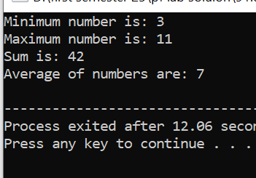
cout<<"Maximum number is: "<<answ2<<endl;
average=sum/6;
cout<<"Sum is: "<<sum<<endl;
cout<<"Average of numbers are: "<<average<<endl;
return 0; }
Q 2:
Take 20 integer inputs from user and print the following: number of positive numbers number of negative numbers number of odd numbers number of even numbers number of 0.
#include <iostream>

using namespace std;

int main(){
int arr[20]={-5,-4,-3,-2,-1,0,1,2,3,4,5,6,7,8,9,10,11,12,13,14};
cout<<"All number are: "<<endl;
for(int i=0; i<20; i++){
cout<<arr[i]<<" ";
}
cout<<"\nEven numbers are: "<<endl;
for(int i=0; i<20; i++){
if(arr[i]%2==0){
cout<<arr[i]<<" ";
}
}
cout<<"\nOdd Numbers are: "<<endl;
for(int i=0; i<20; i++){
if(arr[i]%2!=0){
cout<<arr[i]<<" ";
}
}
cout<<"\nPositive numbers Numbers are: "<<endl;
for(int i=0; i<20; i++){
if(arr[i]>0){
cout<<arr[i]<<" ";
}
}
cout<<"\nNegative numbers Numbers are: "<<endl;
for(int i=0; i<20; i++){
if(arr[i]<0){
cout<<arr[i]<<" ";
}
}
cout<<"\nnumber of 0: "<<endl;
for(int i=0; i<20; i++){
if(arr[i]==0){
cout<<arr[i]<<" ";
}
}
return 0;
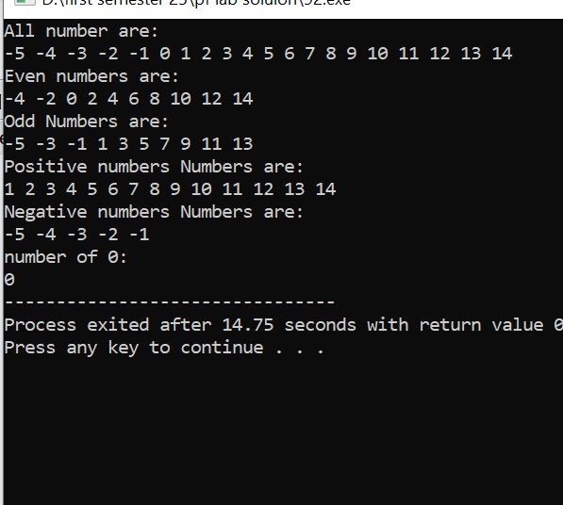
}

Q 3:
Write a program that allows the user to input a series of numbers until they enter a negative number. Store these numbers in an array and then find and print the sum of all the positive numbers entered
#include <iostream>

using namespace std;

int main(){
int serries;
int sum=0;
cin>>serries;
int num[serries];
cout<<"enter the number: ";
for(int i=0; i<serries; i++){
cin>>num[i];
if(num[i]>0){
sum+=num[i];
}
}
cout<<"Sum of serries is : "<<sum<<" ";
return 0;
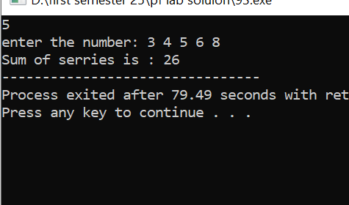
}

Q 4:
Design a program that takes 5 integer inputs from the user and stores them in an array. Find and print the frequency of each unique number in the array.
#include <iostream>

using namespace std;

int main(){
int n;
cout<<"Enter the number of elements : ";
cin>>n;

int num[n],freq[n];
cout<<"Enter the number of : ";
for(int i=0; i<n; i++){
cin>>num[i];
freq[i]=-1;
}
for(int i=0; i<n; i++){
int count=1;
if(freq[i]!=-1){
continue;
}
for(int j=i+1; j<n; j++){
if(num[i]==num[j]){

count++;
freq[j]=0;
}
}
cout<<num[i]<<" apperas "<<count<<" times "<<endl;
}
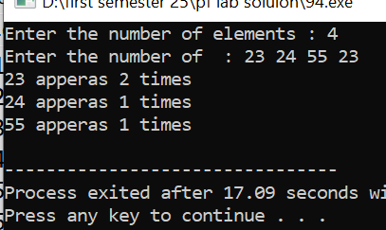
return 0;
}

Q 5:
#include <iostream>

using namespace std;

int main(){
int x,n;
cout<<"Enter the size of array: ";
cin>>n;
int num[n];
cout<<"Enter the number: ";
for(int i=0; i<n; i++){
cin>>num[i];
}

for(int i=0; i<n; i++){
for(int j=i+1; j<n; j++){
if(num[i]<num[j]){

x=num[i];
num[i]=num[j];
num[j]=x;
}
}
}
cout<<"Second largest: "<<num[1]<<endl;

for(int i=0; i<n; i++){
for(int j=i+1; j<n; j++){
if(num[i]>num[j]){

x=num[i];
num[i]=num[j];
num[j]=x;
}
}
}

cout<<"second smallest: "<<num[1]<<endl;
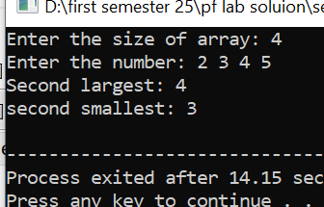
return 0;
}

Q 6:
Ask the user to enter the size of an array (N). Then, ask them to enter N integers. Check if the array is sorted in ascending order and display an appropriate message. (if it’s not sorted, then sort it using the bubble sort method)
#include <iostream>
using namespace std;
int main(){
int n;
cout<<"Enter the size: ";
cin>>n;
int arr[n];
for(int i=0; i<n; i++){
cin>>arr[i];
}
bool sorted=true;
for(int i=0; i<n; i++){
if(arr[i]>arr[i+1]){
sorted=false;
break;
}
}
if(sorted){
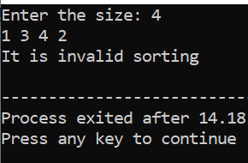
cout<<"It is valid sorting"<<endl;
}
Else
cout<<"It is invalid sorting"<<endl;

return 0; }
Q 7:
Sales Report
Imagine you work for a retail company, and you are responsible for generating a sales report. You have a list of products sold, including the product name, quantity sold, and price per unit. Write a program that calculates the total revenue for each product and the overall total revenue. Format the output using setw to display the report neatly.
#include <iostream>
#include<iomanip>

using namespace std;

int main(){
int n;
cout<<"Enter the numbe of prouct: ";
cin>>n;
string name[n];
int qty[n];
float price[n],total[n];
for(int i=0; i<n; i++){
cout<<"Enter the product name: ";
cin>>name[i];
cout<<"Enter the quantity: ";
cin>>qty[i];
cout<<"Enter the per product price: ";
cin>>price[i];
total[i]=qty[i]*price[i];
}
float bigtotal=0;
for(int i=0; i<n; i++){
bigtotal+=total[i];
}
cout<<"\n\n=============================SALES REPORT========================\n"<<endl;
cout << left << setw(15) << "Product"
<< setw(10) << "Qty"
<< setw(15) << "Price/Unit"
<< setw(15) << "Total Revenue" << endl;
cout<<"----------------------------------------------------------------------\n"<<endl;
for (int i = 0; i < n; i++) {
cout << left << setw(15) << name[i]
<< setw(10) << qty[i]
<< setw(15) << price[i]
<< setw(15) << total[i] << endl;
}

cout<<"----------------------------------------------------------------------\n"<<endl;
cout<<left<<setw(25)<<"Overall Revenue: "<<bigtotal<<endl;

return 0;
}

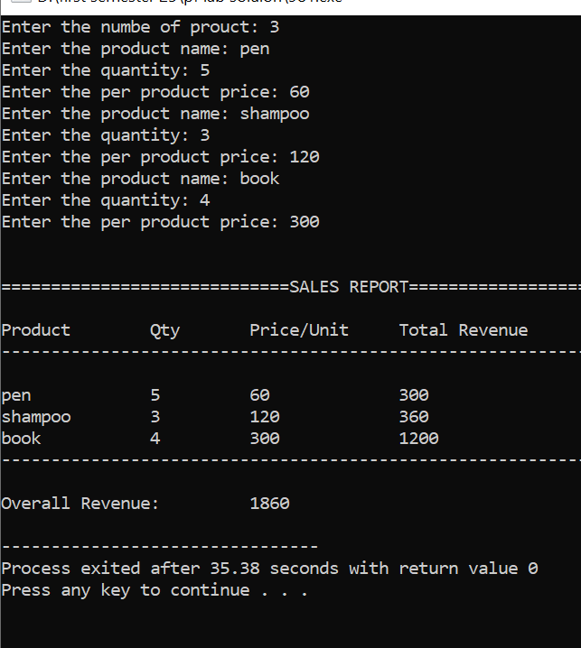

Q 8:
Student Enrollment Design a program that manages student enrollment in courses. The program should allow users to add students to courses and display a list of enrolled students for each course. Use loops and conditional statements to achieve this.
#include <iostream>
#include<iomanip>
using namespace std;
int main(){
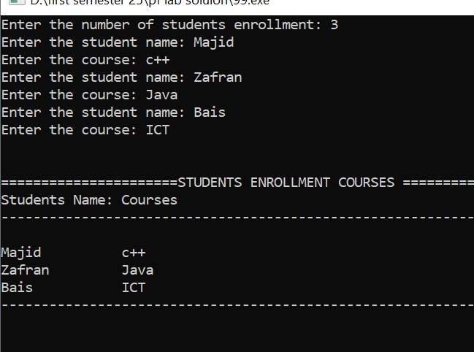
int n;
cout<<"Enter the number of students enrollment: ";
cin>>n;
string name[n],course[n];

for(int i=0; i<n; i++){
cout<<"Enter the student name: ";
cin>>name[i];
cout<<"Enter the course: ";
cin>>course[i];
}
cout<<"\n\n======================STUDENTS ENROLLMENT COURSES =================="<<endl;
cout << left << setw(15) << "Students Name:"
<< setw(18) << "Courses"<<endl;
cout<<"--------------------------------------------------------------------\n"<<endl;
for (int i = 0; i < n; i++) {
cout << left << setw(15) << name[i]
<< setw(16) << course[i]<<endl;
}
cout<<"--------------------------------------------------------------------\n"<<endl;
return 0;}
Q 9:
Write a C++ program that asks the user to input an N number of values in an array (means, the size of the array as well as all the values should be input by the user) and then displays those values in reverse order.
#include <iostream>

using namespace std;

int main(){
int n;
cout<<"Enter the size of array: ";
cin>>n;
int arr[n];
for(int i=0; i<n; i++){
cout<<"Enter the value "<<i+1<<":";
cin>>arr[i];
}
cout<<endl;
cout<<"The number in reverse order of are: "<<endl;
for(int i=n-1; i>=0; i--){
cout<<arr[i]<<" ";
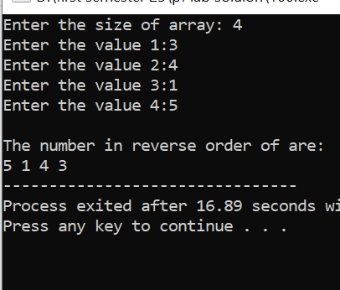
}

return 0;
}

Q 10:
Write a program that gets array size and elements as input from a user and then prints only the EVEN values that are present in the array.
#include <iostream>

using namespace std;

int main(){
int n;
cout<<"Enter the size of array: ";
cin>>n;
int arr[n];
for(int i=0; i<n; i++){
cout<<"Enter the value "<<i+1<<":";
cin>>arr[i];
}
cout<<endl;
cout<<"The Even numbers are: "<<endl;
for(int i=0; i<n; i++){
if(arr[i]%2==0){
cout<<arr[i]<<" ";
}
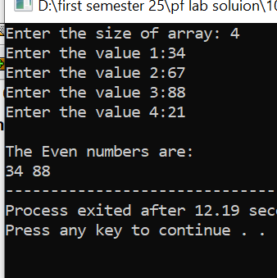
}
return 0;
}

Q 11:
Write a program where you should sum the elements of two same-sized arrays and the result should be saved in the third array. Then, print the values of all of the three arrays. The values of the first two arrays may be given fixed (no need to get input) but each value of the third array should be the sum of respective values from the first and the second arrays.
#include <iostream>

using namespace std;

int main(){
int n;
cout<<"Enter the size of array: ";
cin>>n;
int arr1[n],arr2[n],arr3[n];
cout<<"The values of first array"<<endl;
for(int i=0; i<n; i++){
cin>>arr1[i];
}
cout<<"The values of second array"<<endl;
for(int i=0; i<n; i++){
cin>>arr2[i];
}
cout<<"The values of third array"<<endl;
for(int i=0; i<n; i++){
arr3[i]=arr1[i]+arr2[i];
cout<<arr3[i]<<" ";
}
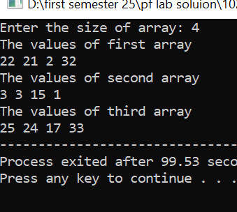
return 0;}
Q 12
Write a program that gets array elements as input from a user and then asks the user to input any value to search from the array. After that, if the value entered by the user is present in the array, it should display the index where that value is present. If the value is NOT present in the array, then it should print a message saying that the given value is not present in the array.
#include <iostream>

using namespace std;

int main(){
int n,index=-1;
cout<<"Enter the size of array: ";
cin>>n;
int arr[n];
for(int i=0; i<n; i++){
cout<<"Enter the value number "<<i+1<<": ";
cin>>arr[i];
}
cout<<endl;
int target;
cout<<"Enter the value which want to search from this array: ";
cin>>target;
for(int i=0; i<n; i++){
if(target==arr[i]){
index=i;
break;
}
}
if(index==-1){
cout<<target<<" is not present in the array";
}
else
cout<<target<<" is present at "<<index+1<<" index"<<endl;

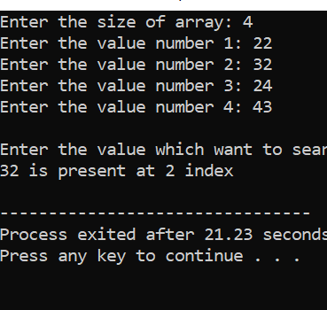
return 0;
}

